Example: Parameters to Local class methods, calling a method from another method
REPORT Z1030OOPS3.
class lcl_emp DEFINITION.
PUBLIC SECTION.
methods set importing i_empno type i
i_ename type c optional.
PROTECTED SECTION.
data : empno type i,
ename(20) type c.
methods display.
endclass.
class lcl_emp IMPLEMENTATION.
method set.
* empno = i_empno. "(or)
me->empno = i_empno.
* ename = i_ename. "(or)
me->ename = i_ename.
* call method display. "(or)
call method me->display.
endmethod.
method display.
write :/ empno,ename.
endmethod.
endclass.
START-OF-SELECTION.
write :/ 'First Object ob1...'.
data ob1 type ref to lcl_emp.
create object ob1.
PARAMETERS : p_empno type i,
p_ename(20) type c.
*call method ob1->set. "syntax error as mandatory parameter value missing
call method ob1->set
EXPORTING
i_empno = p_empno.
*call method ob1->display. "syntax error
uline.
write :/ 'Second Object ob2...'.
data ob2 type ref to lcl_emp.
create object ob2.
call method ob2->set
EXPORTING
i_empno = p_empno
i_ename = p_ename.

Example: Global class method with parameters
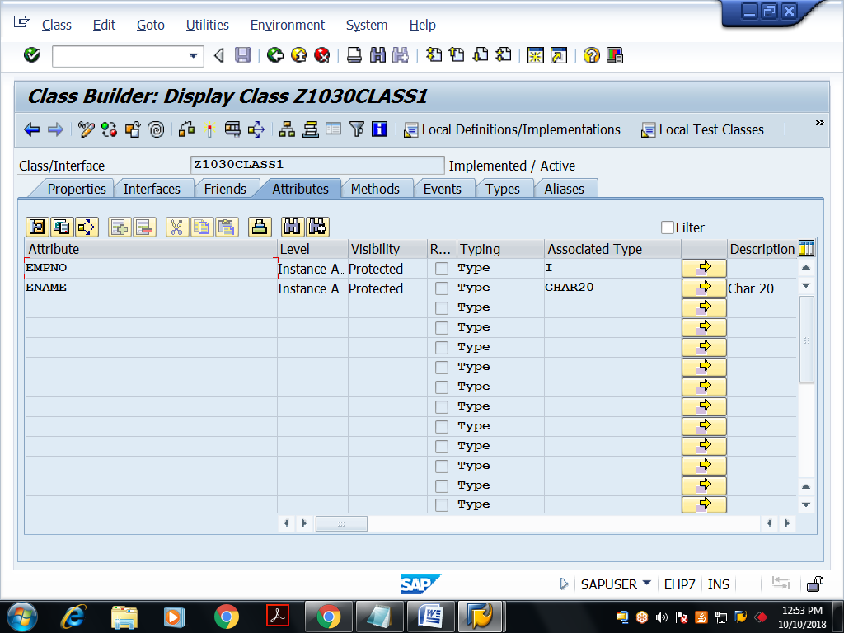
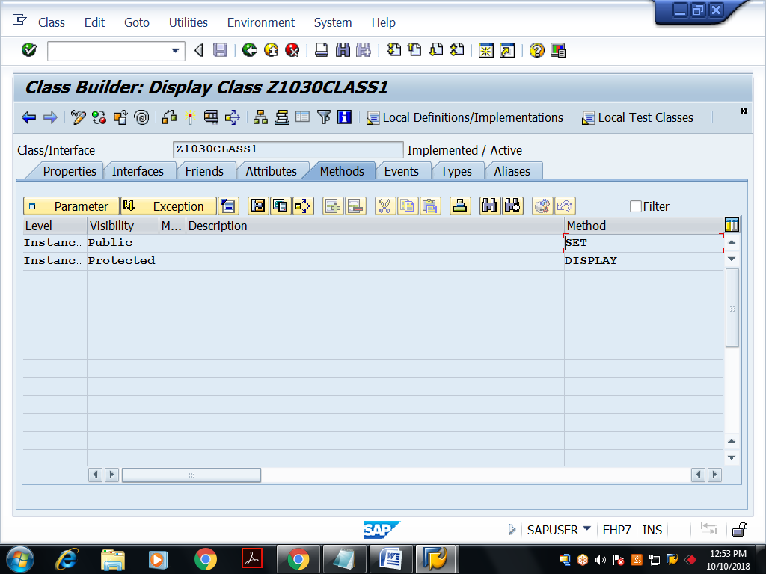

Parameters to ‘SET’ method
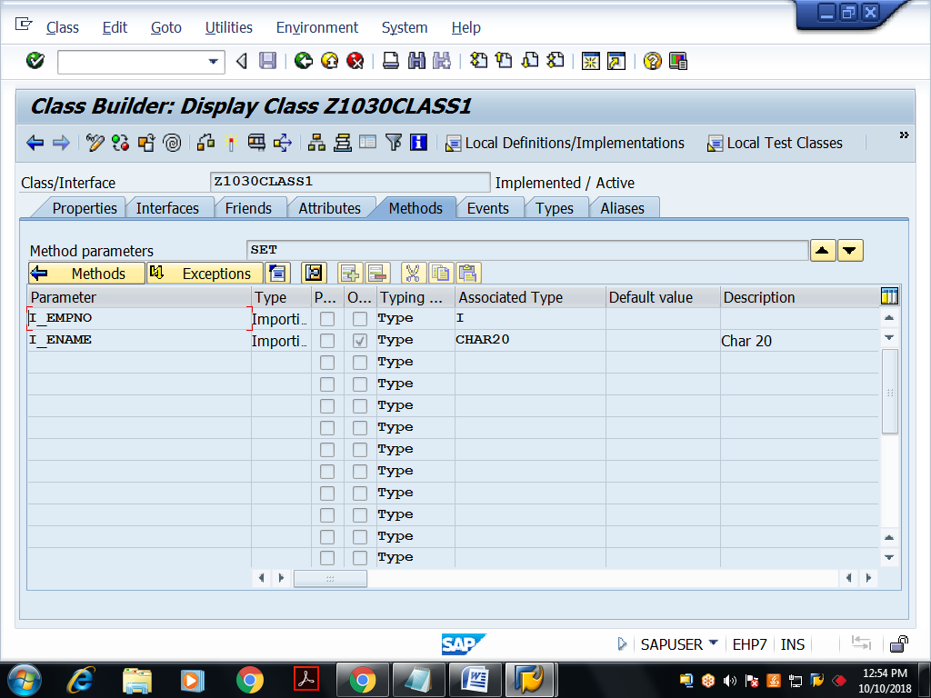
Implementations:
method SET.
empno = i_empno.
ename = i_ename.
call method display.
endmethod.
method DISPLAY.
write :/ empno,ename.
endmethod.
Save, activate the global class

Executable program: For acing above Global class components
REPORT Z1030OOPS4.
data ob type ref to z1030class1.
CREATE OBJECT OB.
PARAMETERS : p_empno type i,
p_ename(20) type c.
CALL METHOD OB->SET
EXPORTING
I_EMPNO = p_empno
I_ENAME = p_ename.
*call method ob->display.

